Aufgabe 11.6

ges.: Höhenunterschied zwischen den Brunnen

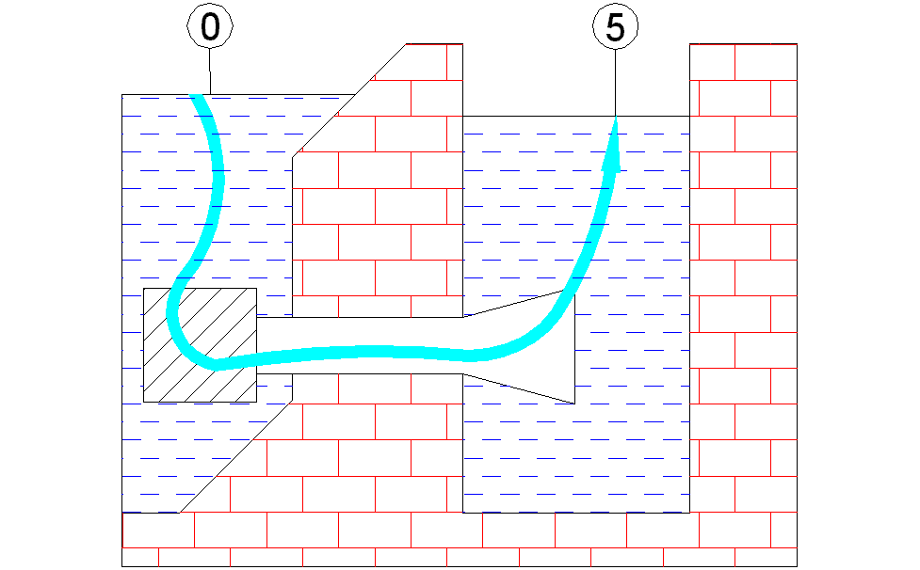

BGL 0 → 5 (Reibungsbehaftet)

$$\begin{aligned}P_{\text{ges}0}=P_{\text{ges}5}+\sum{P_{\text{Vges}0→1}} \\ \frac{ρ}{2}∗c_{0}²+P_{b}+ρ∗g∗h_{0}=\frac{ρ}{2}∗c_{5}²+P_{b}+ρ∗g∗h_{5}+\sum{P_{\text{Vges}0→1}} \\ c_{0}=c_{5}=0 \\ h_{0}=0 h_{5}=−z \\ ρ∗g∗z=\sum{P_{\text{Vges}0→1}} \\ \sum{P_{\text{Vges}0→1}}=\frac{ρ}{2}c_{1}\text{²*}\left(ξ_{k}+λ_{1}∗\frac{ℓ_{1}}{d_{1}}+1\right) \\ ρ∗g∗z\text{==}\frac{ρ}{2}c_{1}\text{²*}\left(ξ_{k}+λ_{1}∗\frac{ℓ_{1}}{d_{1}}+1\right) \\ z=\frac{c_{1}²}{2g}∗\left(ξ_{k}+λ_{1}∗\frac{ℓ_{1}}{d_{1}}+1\right) \\ c_{1}²=\frac{\overset{˙}{v}²}{A²}=\underline{\text{23},7\frac{m²}{s²}} c_{1}=\underline{4,\text{86}\frac{m}{s}} \\ R_{e1}=\frac{c_{1}∗d_{1}}{υ}=\underline{9,\text{36}∗{\text{10}}^{5}} \frac{d_{1}}{k_{s1}}=\underline{\text{125}} ⇒ λ_{1}=\underline{0,\text{036}} \\ \underline{\underline{z=1,\text{876}m}}\end{aligned}$$

ges.: Druck P_{S} im Saugstutzen der Pumpe

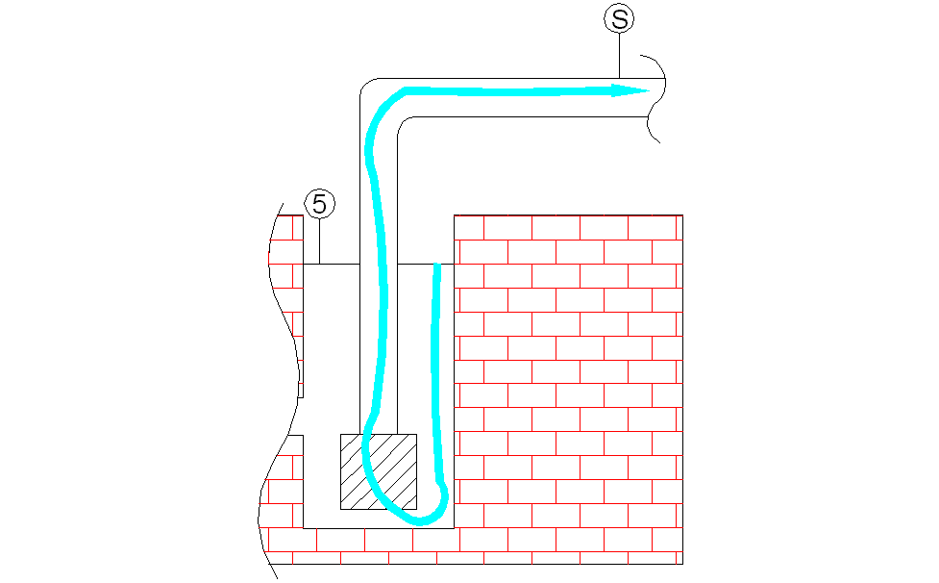

BGL 5 → S

$$\begin{aligned}\frac{ρ}{2}∗c_{5}²+P_{b}+ρ∗g∗−z=\frac{ρ}{2}∗c_{S}²+P_{S}+ρ∗g∗H_{P}+\sum{P_{\text{Vges}5→S}} \\ c_{5}=0 \\ P_{b}+ρ∗g∗−z=\frac{ρ}{2}∗c_{S}²+P_{S}+ρ∗g∗H_{P}+\sum{P_{\text{Vges}5→S}} \\ \sum{P_{\text{Vges}5→S}}=\frac{ρ}{2}∗c_{S}²\left(ξ_{k}+ξ_{\hat{\text{kr}}}+λ_{2}∗\frac{ℓ_{2}}{d_{2}}\right) \\ P_{b}+ρ∗g∗−z=\frac{ρ}{2}∗c_{S}²+P_{S}+ρ∗g∗H_{P}+\frac{ρ}{2}∗c_{S}²\left(ξ_{k}+ξ_{\hat{\text{kr}}}+λ_{2}∗\frac{ℓ_{2}}{d_{2}}\right) \\ P_{S}=P_{b}−ρ∗g(z+H_{p})−\frac{ρ}{2}∗{\left(\frac{4∗\overset{˙}{v}}{π∗d_{2}²}\right)}^{2}∗\left(ξ_{k}+ξ_{\hat{\text{kr}}}+λ_{2}∗\frac{ℓ_{2}}{d_{2}}\right) \\ {\text{Re}}_{2}=\frac{c_{S}∗d_{2}}{υ}=\underline{7,7∗{\text{10}}^{5}} \frac{d}{k}⇒\text{nicht} \text{vorhanden} \text{da} \text{hydraulisch} \text{glatt} \\ λ_{2}=\underline{0,\text{0122}} \\ \underline{\underline{P_{S}=5,\text{235}∗{\text{10}}^{4}\text{Pa}}}\end{aligned}$$

ges.: Drucksprung der Pumpe

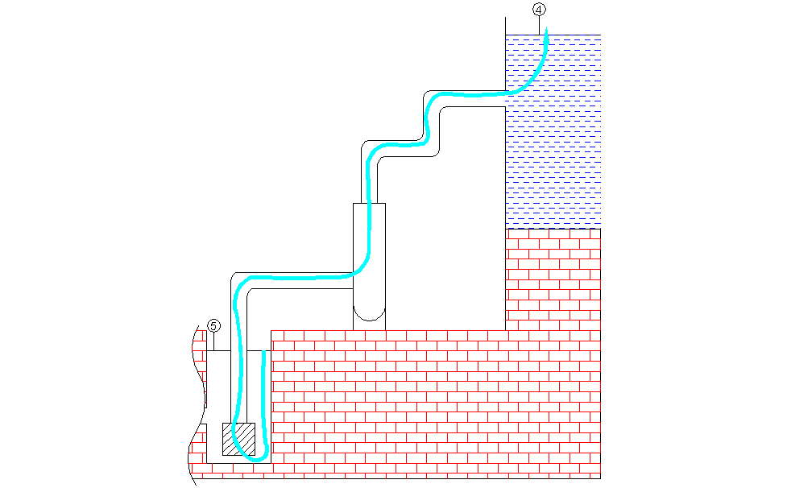

BGL 5 → 4

$$\begin{aligned}P_{\text{ges}5}=P_{\text{ges}4}+\sum{P_{\text{Vges}5→4}−{ΔP}_{P}} \\ \frac{ρ}{2}∗c_{5}²+P_{b}+ρ∗g∗−z=\frac{ρ}{2}∗c_{4}²+P_{b}+ρ∗g∗(H_{P}+H_{k})+\sum{P_{\text{Vges}5→4}−{ΔP}_{P}} \\ c_{5}=c_{4}=0 \\ {ΔP}_{P}=ρ∗g∗(z+H_{P}+H_{k})+\sum{P_{\text{Vges}5→4}} \\ \sum{P_{\text{Vges}5→4}}=\frac{ρ}{2}c_{S}\text{²*}\left(ξ_{k}+ξ_{\hat{\text{kr}}}+λ_{2}∗\frac{ℓ_{2}}{d_{2}}\right)+\frac{ρ}{2}c_{3}\text{²*}\left(3ξ_{\hat{\text{kr}}}+λ_{3}∗\frac{ℓ_{3}}{d_{3}}+1\right) \\ {\text{Re}}_{3}=\frac{c_{3}∗d_{3}}{ν}=9,\text{63}∗{\text{10}}^{5} λ_{3}=0,\text{0115} (\text{Rohr} 3 \text{hydraulisch} \text{glatt}) \\ \underline{\underline{{ΔP}_{P}=1,\text{177}∗{\text{10}}^{5}\text{Pa}}}\end{aligned}$$

